Secure your API’s with Azure Application Gateway and Azure API Management
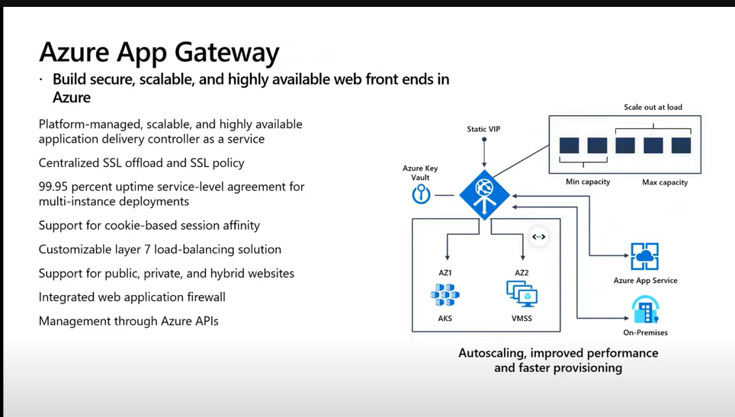

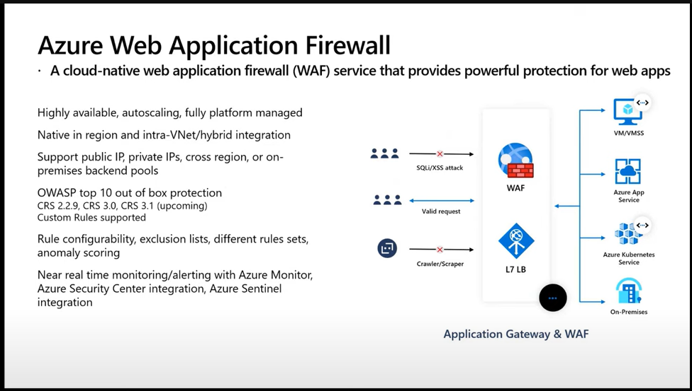

Azure API Management helps customers meet these challenges:
- Abstract backend architecture diversity and complexity from API consumers
- Securely expose services hosted on and outside of Azure as APIs
- Protect, accelerate, and observe APIs
- Enable API discovery and consumption by internal and external users

API Management components
Azure API Management is made up of an API gateway, a management plane, and a developer portal. These components are Azure-hosted and fully managed by default. API Management is available in various tiers differing in capacity and features.
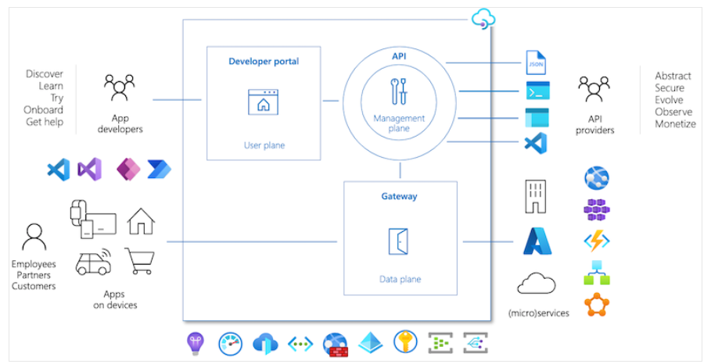

API gateway
All requests from client applications first reach the API gateway, which then forwards them to respective backend services. The API gateway acts as a facade to the backend services, allowing API providers to abstract API implementations and evolve backend architecture without impacting API consumers. The gateway enables consistent configuration of routing, security, throttling, caching, and observability.
Specifically, the gateway:
- Acts as a facade to backend services by accepting API calls and routing them to appropriate backends
- Verifies API keys and other credentials such as JWT tokens and certificates presented with requests
- Enforces usage quotas and rate limits
- Optionally transforms requests and responses as specified in policy statements
- If configured, caches responses to improve response latency and minimize the load on backend services
- Emits logs, metrics, and traces for monitoring, reporting, and troubleshooting

Management plane
API providers interact with the service through the management plane, which provides full access to the API Management service capabilities.
Customers interact with the management plane through Azure tools including the Azure portal, Azure PowerShell, Azure CLI, a Visual Studio Code extension, or client SDKs in several popular programming languages.
Use the management plane to:
- Provision and configure API Management service settings
- Define or import API schemas from a wide range of sources, including OpenAPI specifications, Azure compute services, or WebSocket or GraphQL backends
- Package APIs into products
- Set up policies like quotas or transformations on the APIs
- Get insights from analytics
- Manage users

Developer portal
The open-source developer portal is an automatically generated, fully customizable website with the documentation of your APIs.
Using the developer portal, developers can:
- Read API documentation
- Call an API via the interactive console
- Create an account and subscribe to get API keys
- Access analytics on their own usage
- Download API definitions
- Manage API keys
Integration with Azure services
API Management integrates with many complementary Azure services to create enterprise solutions, including:

Azure Key Vault for secure safekeeping and management of client certificates and secrets
Azure Monitor for logging, reporting, and alerting on management operations, systems events, and API requests
Application Insights for live metrics, end-to-end tracing, and troubleshooting
Virtual networks, private endpoints, and Application Gateway for network-level protection
Azure Active Directory for developer authentication and request authorization
Event Hubs for streaming events
Several Azure compute offerings commonly used to build and host APIs on Azure, including Functions, Logic Apps, Web Apps, Service Fabric, and others.

